LAB 2:
1 Download the dataset :
https://media.geeksforgeeks.org/wp-content/uploads/20240319120216/housing.csv
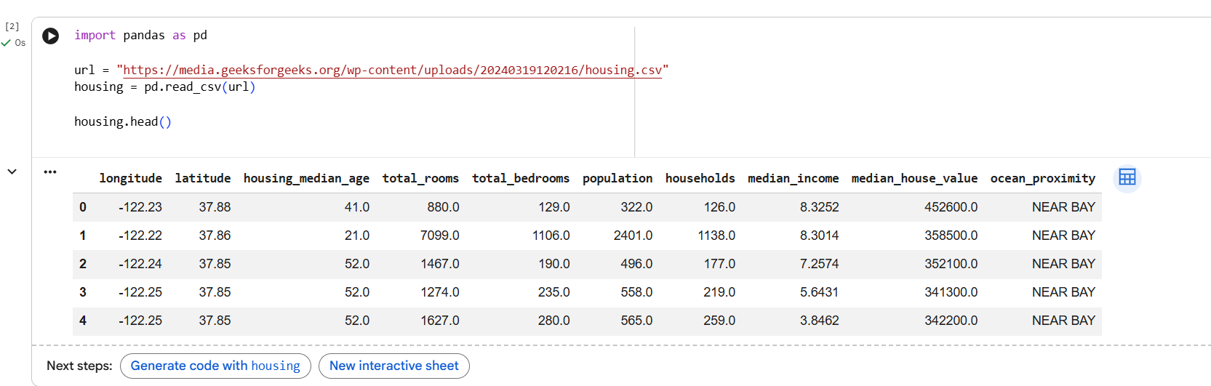

- Perform the describe and info steps
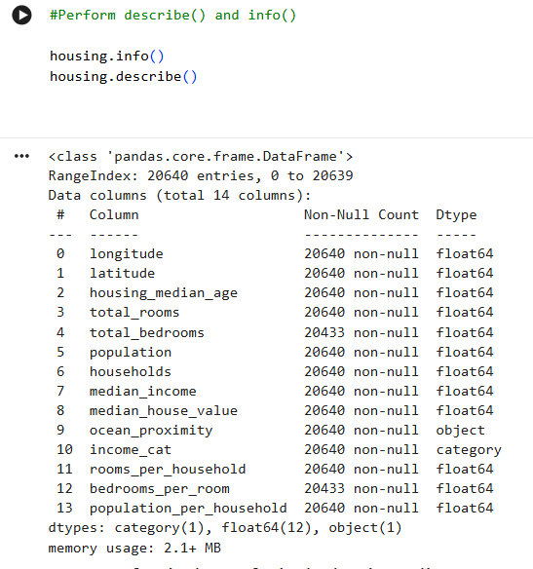
- Plot the histogram of each feature( Indicate what does histogram indicate on median_income and house_median_age)

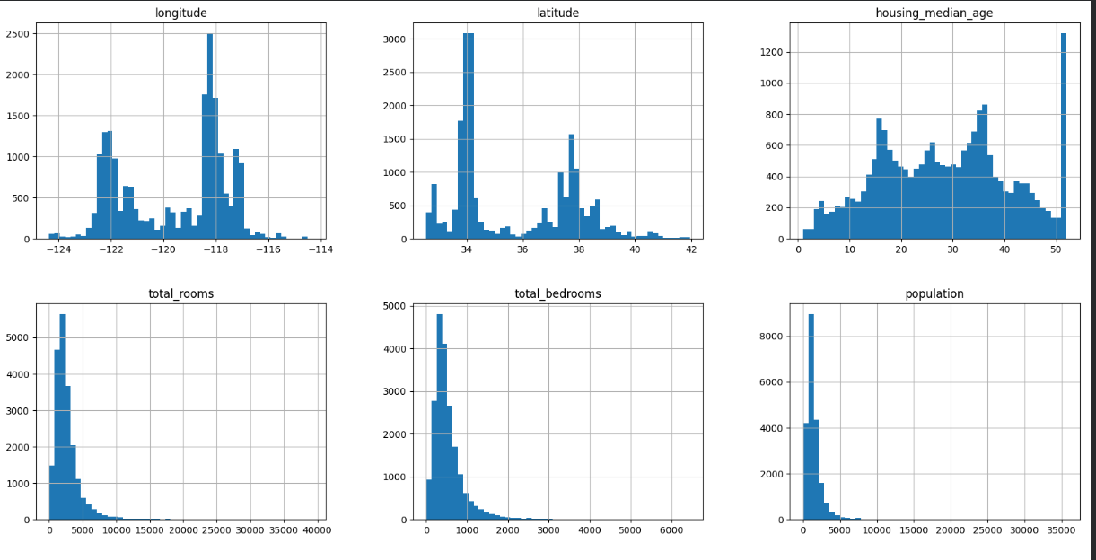
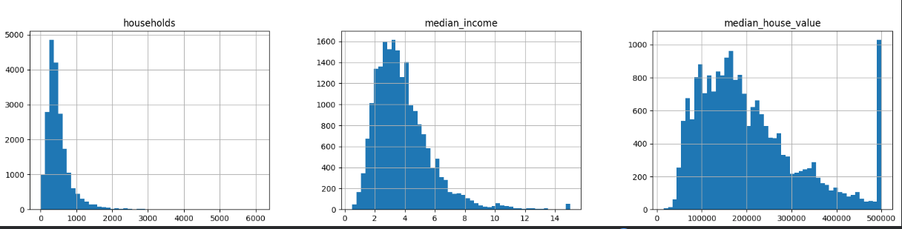
- Demonstrate the process of creating a test set( write the difference between random and stratified test set)

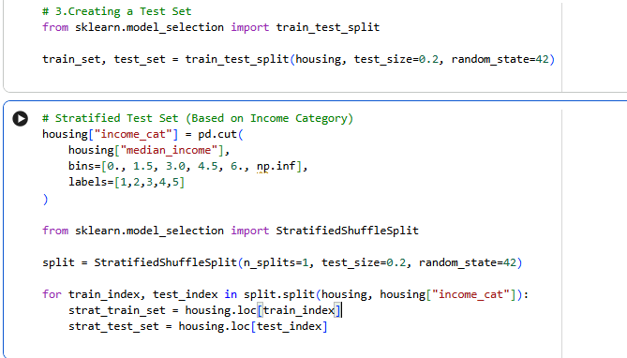
- List the geographical features from the dataset and plot a graph to Visualize Geographical Data(what does the graph indicate w.r.t housing prices and location)
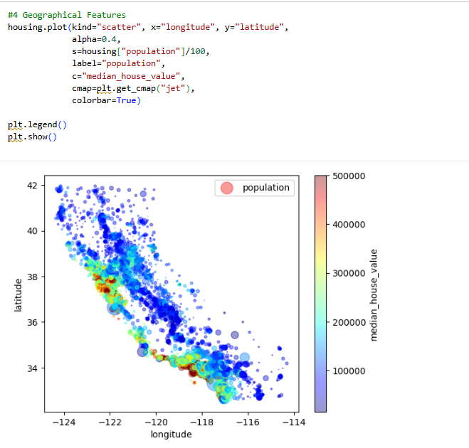
- Plot a graph to show features correlation with housing price. Which feature corelates to the maximum. Plot the graph for that with housing price and analyze what the graph indicate
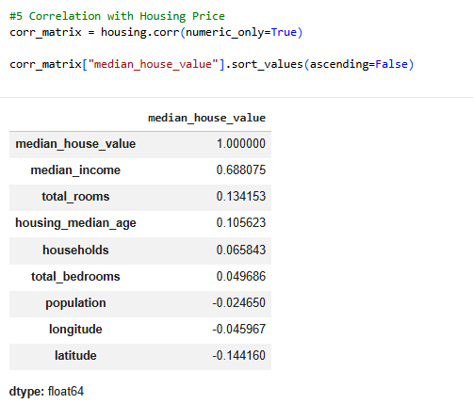
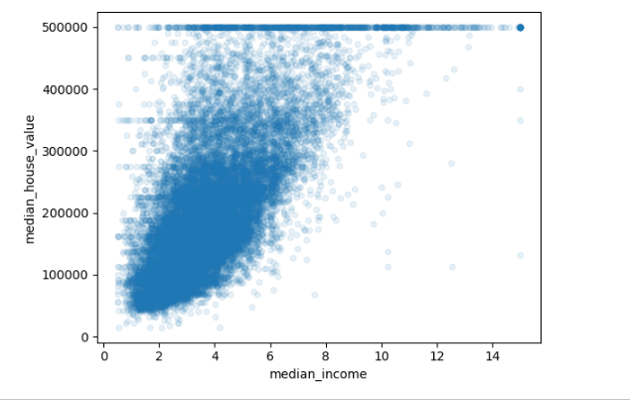

- List the features that could be combined to improve correlation and plot again to see if correlation has improved

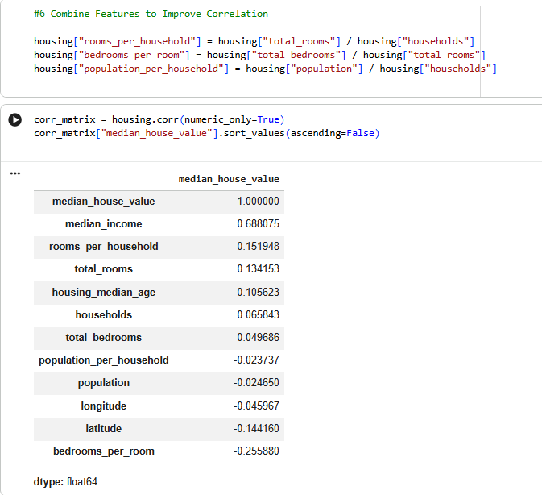

- List the features that needs to be cleaned and demonstrate the process of cleaning

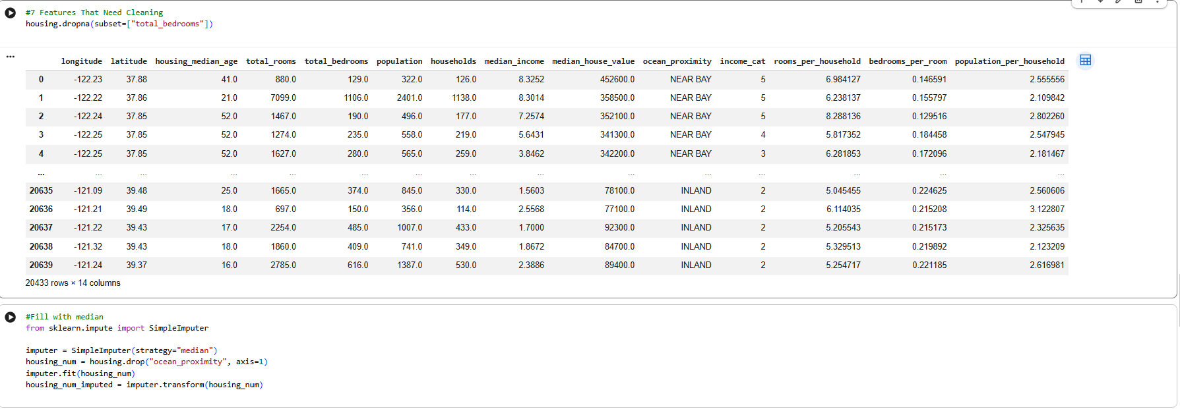
- Is there any categorical data that needs to be converted to numerical? If so explain the method used to convert and code the same and show the output.
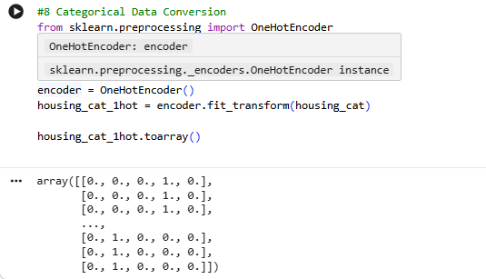
- Discuss the importance of feature scaling
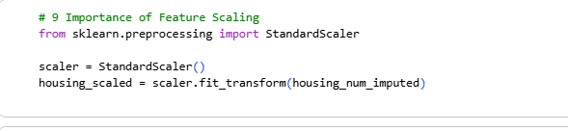
- Design a pipeline inculcating (Custom transform, feature scaling and encoding). Explain how it works

